Business Process Flow
03 June 2025
11:21

- A BPF in MSd 365 crm is visual guide , guided proecss which help users to follow a set of steps of complete a business task efficiently and consistently.
- Core Components of a BPF

Stage - Major Phase in process.
Data steps, Action step ,conditions , workflow/automation, flow step

process flow control - controls like next stage, previous stage and finish that guides the users through the process.
Action step - It is used to call a custom action that performs a specific task such as
- Sending an email
- Creating a related record
- Updating a field
- Calling a Power Automate flow
- Running a plugin or custom logic

Other terms -

Order process of bpf
Security roles

Questions -

Can a BPF span multiple entities? How does that work

Yes , Upto 5 entities
These entities must be connected through 1:N or N:1 relationships.

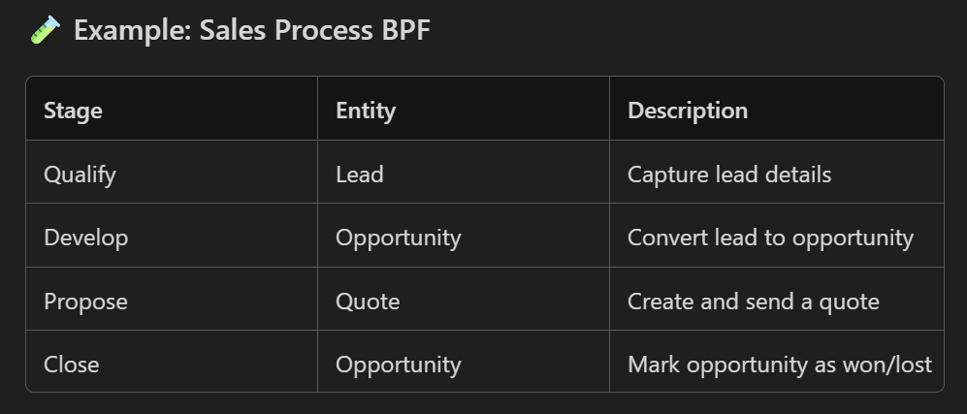

2. What are the limitations of Business Process Flows?
Here are the official BPF limitations:
⚠ Structural Limits
- Max 30 stages per BPF
- Max 5 entities in a multi-entity BPF
- Only 10 BPFs can be active per record
- Only 1 active BPF at a time
⚠ Functionality Limits
- Cannot perform calculations
- No advanced UI customization
- Limited conditional logic (basic OR/AND branches only)
- Cannot reference fields that aren’t on form
- No looping logic
- Cannot trigger on-demand like workflows
⚠ Performance/Usability
- Very large BPFs slow down forms
- Cannot embed custom controls inside BPF steps
- Poor for highly complex approval paths

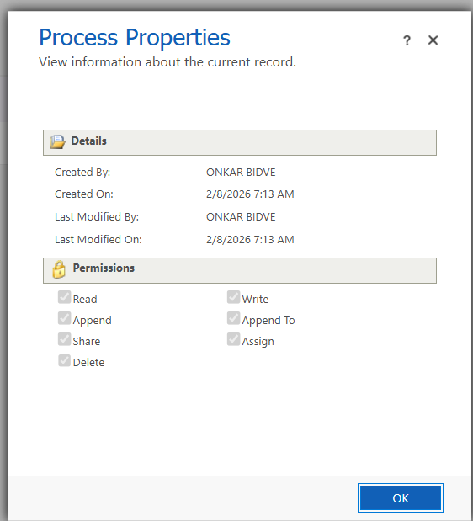

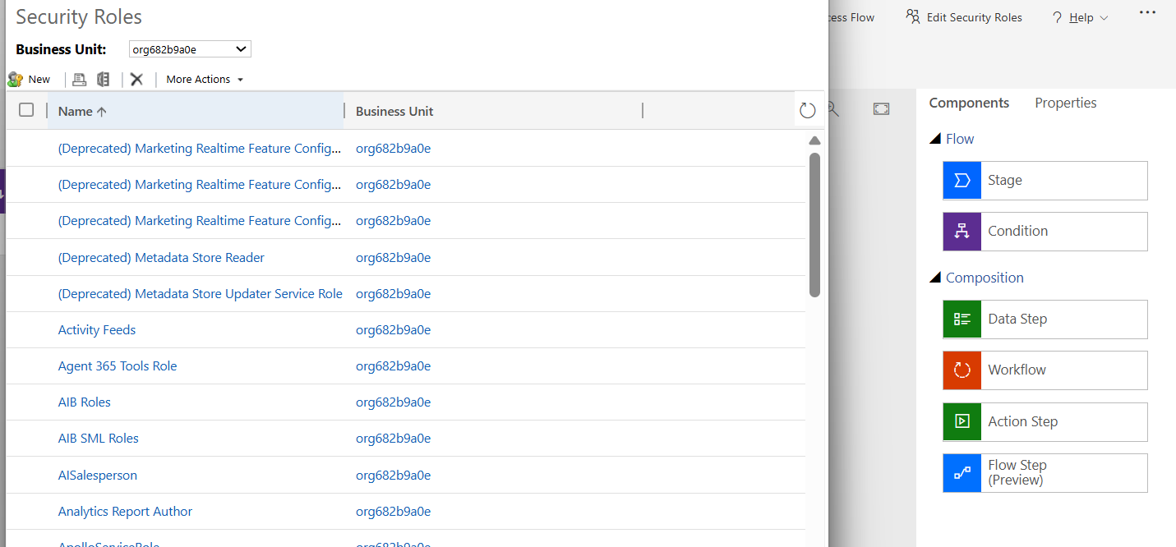

Worflow
03 June 2025
12:42
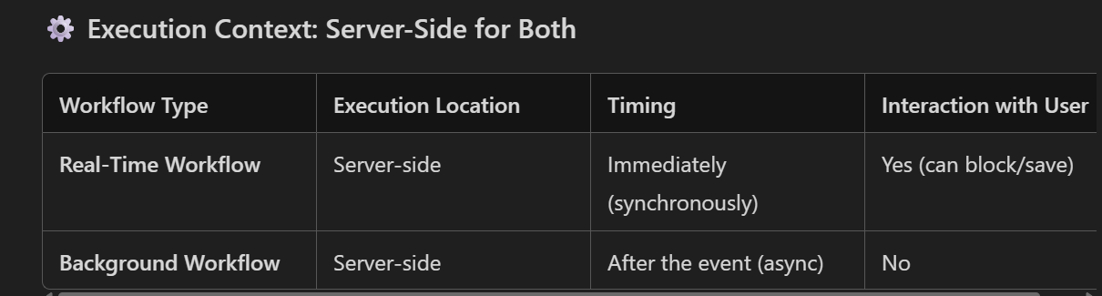

Note:

- Real Time workflow used for instant feedback .
- Like preventing to save a record.

Steps to prevent save
- Add condition and stop workflow use cancelled and give error message. If used succeded will save the record.

Workflow As a child process -

- Child process refers to a workflow that is called or triggered by another (parent)workflow. This allows you to modularize your automation logic, making it easier to manage, reuse, and maintain.

Example Scenario:

Parent Workflow: Runs when a new case is created.
Child Workflow: Sends a welcome email to the customer.

The parent workflow checks if the case type is "Support".
If yes, it calls the child workflow to send the email.

Workflow as on-demand process -

- An on-demand process in Dynamics 365 workflows (also known as a manual workflow) is a workflow that is not triggered automatically by a system event (like record creation or update), but instead is manually started by a user when needed.

Scope :

- The scope defines the security boundary for the workflow execution. It controls whose data the workflow will act on when triggered.

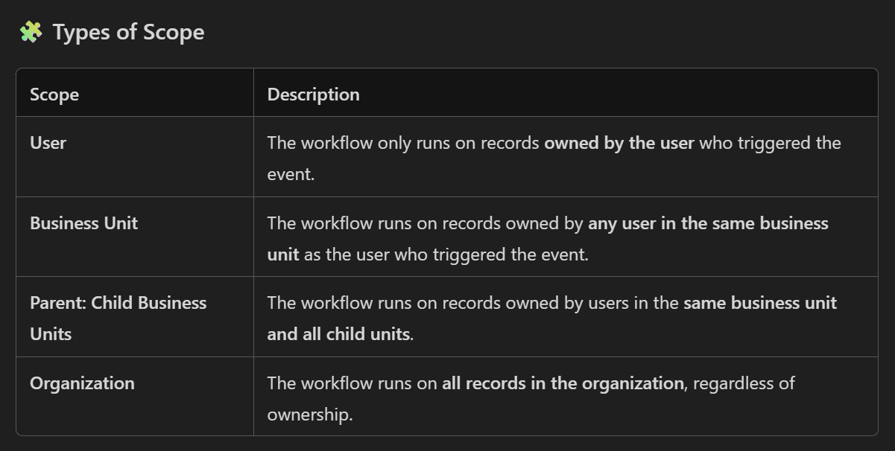

Trigger points -

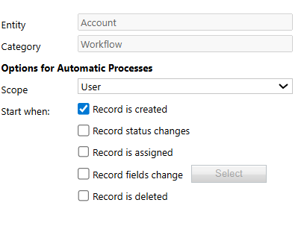

Steps -

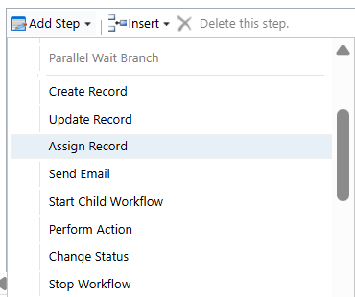

Steps -

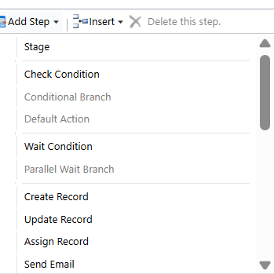

Limitations of work flows -
- Cannot work on related entities
- Cannot handle the complex logic
- Limited triggers and steps
- No external api calls

Automatic Record Creation And Updation And Routing Rules
03 June 2025
15:10

- Automatic Record Creation and Update (ARC) feature allows you to automatically create or update records—like cases, leads, or custom entities—based on incoming activities such as emails, social posts, or other interactions.

- ARC rules help automate the creation or updating of records when certain conditions are met.

- Creating cases from emails
- Updating existing cases with replies
- Routing social media messages
- Triggering workflows or Power Automate flows

Key Components :

-Rule sets

Step 1: detail
Name , queue association , and Activity type to monitor e.g email,phone

Step 2: condition and action - action to create or update the type (entity) record.

Step 3: additional actional after matching the condition. e.g - automatic email reply

Routing Rules

- Routing rules are logic-based configurations that determine where a record should go after it's created or updated.
- They help ensure that work is distributed efficiently and handled by the right people.

- The routing rule set have create the rule item.

Automatic Record Creation And Updation And Routing Rules
03 June 2025
15:10

- Automatic Record Creation and Update (ARC) feature allows you to automatically create or update records—like cases, leads, or custom entities—based on incoming activities such as emails, social posts, or other interactions.

- ARC rules help automate the creation or updating of records when certain conditions are met.

- Creating cases from emails
- Updating existing cases with replies
- Routing social media messages
- Triggering workflows or Power Automate flows

Key Components :

-Rule sets

Step 1: detail
Name , queue association , and Activity type to monitor e.g email,phone

Step 2: condition and action - action to create or update the type (entity) record.

Step 3: additional actional after matching the condition. e.g - automatic email reply

Routing Rules

- Routing rules are logic-based configurations that determine where a record should go after it's created or updated.
- They help ensure that work is distributed efficiently and handled by the right people.

- The routing rule set have create the rule item.

Hierarchy Security:
It allows users to access records owned by their subordinates based on their position in the organizational hierarchy.
1.Manager Hierarchy
- A manager must be within the same business unit as the subordinates, or in the parent business unit of the subordinate’s business unit, to have access to the subordinate’s data.
- Managers can access records owned by their direct and indirect subordinates, depending on the hierarchy depth.
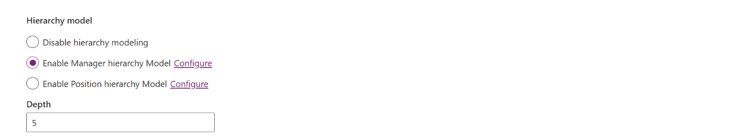
Example:
If User A is the manager of User B, and User B owns a lead, User A can access that lead.
- Security>hierarchy security
- Manager Hierarchy only works if the manager is in the same BU or in the parent BU not the child.
Applying This to our Case
Eagle Hills BU = Parent BU
UAE BU = Child BU
UAE user is in UAE BU
UAE user to be the manager of users in Eagle Hills BU
This will not work, because the UAE user is in the child BU, and the users they need to manage are in the parent BU.

2. Position Hierarchy:
Based on the custom position which are configured in system.
Position Hierarchy does not require users to be in the same BU.
Position Hierarchy is designed to work across Business Units but only for access of records.
Positions need to configure using -
Security > positions

Example images:
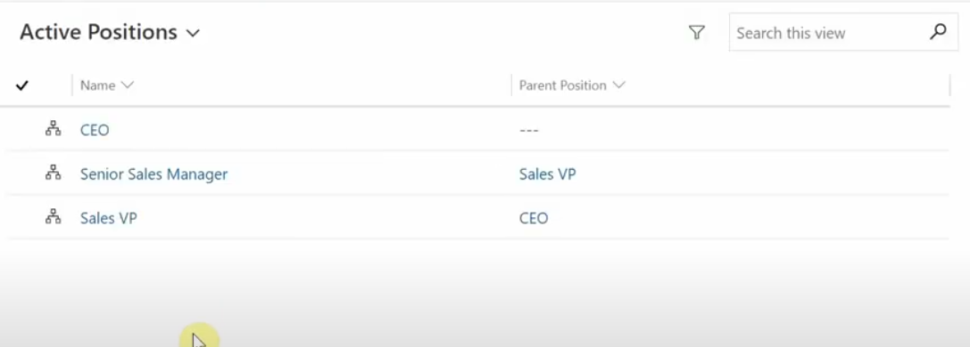
image: Position hierarchy
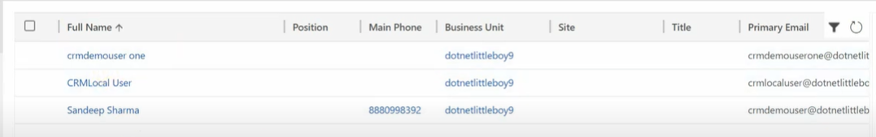
image: users in system
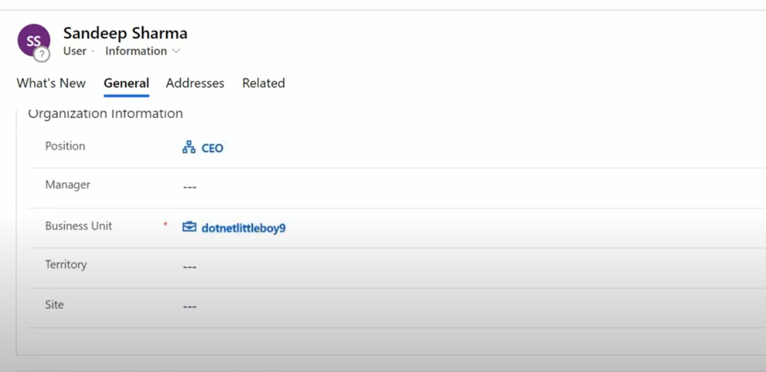image: Assigning the position as CEO to user.
- In our case we can create a position for manager uae and add user in it and also can create position for user add users to it. And assign the parent position as Manager position to the eagle hills user’s position.
For example:
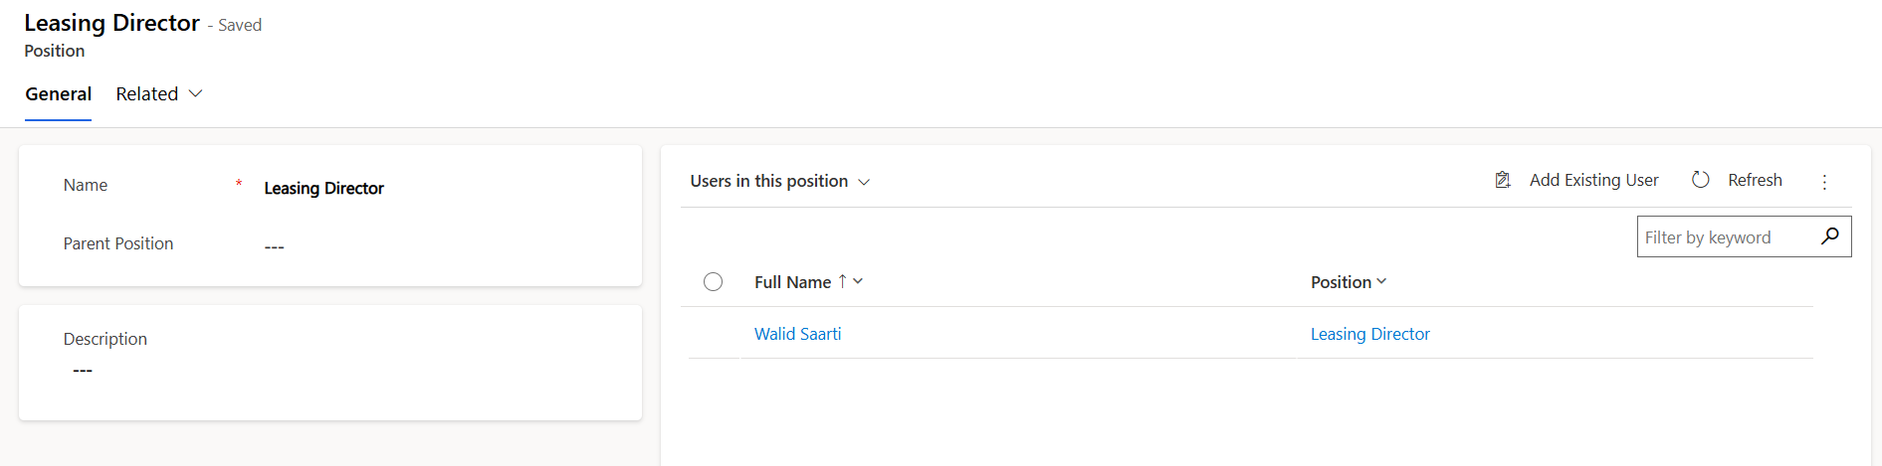image: Parent Position

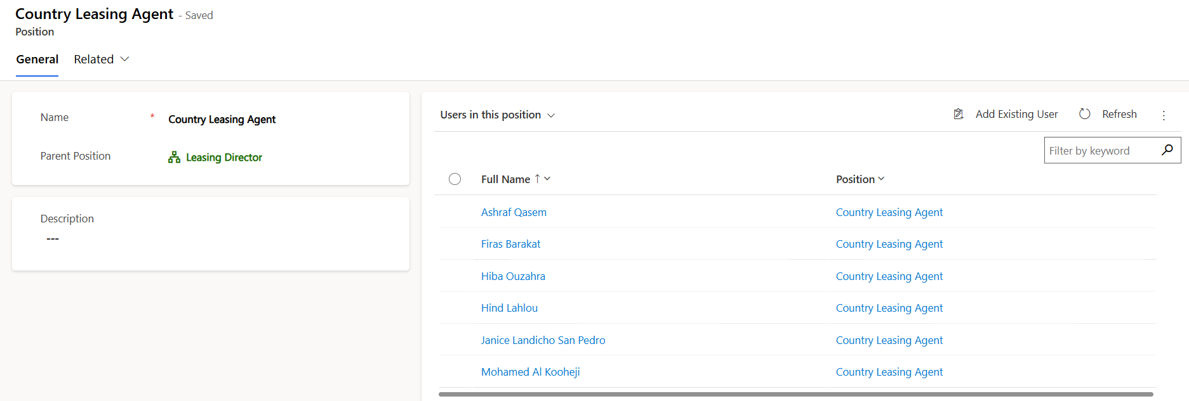image: Child position

- UAE user will have access to the records of five user in the eagle hills bu.
Since UAE user (in a higher position) to access records owned by 5 Eagle Hills users (in lower positions)
- The UAE user is one level above the Eagle Hills users in the position hierarchy,
- And the if Eagle Hills users are not managing other users below them,
Then only need a Hierarchy Depth of one.
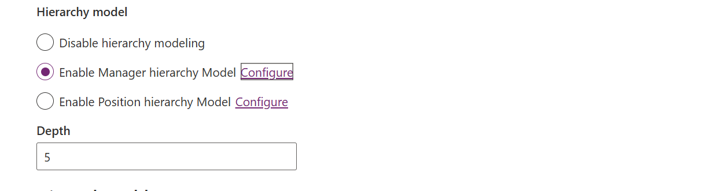

Polymorphic Lookup
23 September 2025
11:56

- It is a lookup field which is used for adding the multiple table records with a single field.
- allows a single lookup field to reference records from multiple different tables

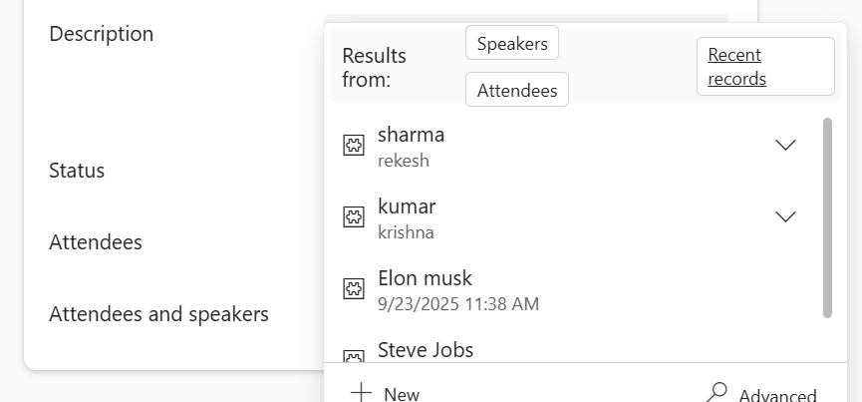

Attendees and speakers records in Event table with Attendees and speakers lookup.

Limitation :
- Only one record can recorded at once . Not flexible to add multiple records in single lookup field.

- Multi-Select Lookup :-

Alternate key
23 November 2025
23:45
1.Alternate key gets failed if the fields on which alternate key is created has duplicate values in the system .Due to this the status becomes failed
2.After removing the duplicating values form the system the retry the key and status becomes active

- Alternate key can be created with one coloumns and more than 1 coloumn

Currency
02 December 2025
22:03
- Base Currency
- Definition:
The organization’s default currency used for storage, calculations, and reporting.
- Set During Organization Setup:
Once set, it cannot be changed without creating a new organization.
- Impact:
All monetary values are stored internally in Base Currency (e.g., INR in your case).
- Example:
If Base Currency = INR, every transaction is calculated in INR internally.

- Transaction Currency :

Additional Currencies
- can add multiple currencies (USD, EUR, GBP, etc.) for transactions.
- Each currency requires:
  - Currency Code (e.g., USD)
  - Currency Symbol ($)
  - Precision (decimal places)
  - Conversion Rate (against Base Currency)
    - Example: INR 1.00 = 0.012 USD

Example Scenario
Organization Base Currency: INR
User Personalization Default Currency: USD
Exchange Rate: INR 1.00 = 0.012 USD
E.g -
Step 1: User Creates a New Opportunity
- Currency field auto-populates with USD (because of Personalization setting).
- User enters Amount = 1,000 USD.

Step 2: System Behavior
- Internally, CRM converts 1,000 USD to INR using the exchange rate:
1,000 USD ÷ 0.012 = 83,333.33 INR
- Stored value = 83,333.33 INR (Base Currency).

Step 3: Display
- For this user:
  - Shows $1,000.00 in forms and views (because default currency = USD).
- For another user with Indian format:
  - Shows ₹83,333.33 (converted back to INR for display).

- Personalized setting - Set to default currency - usd and In formats currency format is Chinese then -
- Personalization Settings:
  - Default Currency: USD
  - Currency Format: Chinese (e.g., grouping and symbol style like ￥1,234.56)
- Organization Base Currency: INR

Example:
- You create an Opportunity:
  - Amount: 1,000 USD (auto-selected because of default currency).
  - Display: usd 1,000 (but of Chinese format).
  - Date as 1-1-2025 (e.g chinese format)
  - Internally stored: 83,333.33 INR (if INR 1 = 0.012 USD).

Behavior:
- Default Currency (USD):
  - When you create a new record (Opportunity, Quote, etc.), the Currency field will auto-populate with USD.
  - Internally, CRM converts USD to INR using the exchange rate for calculations and reporting.
- Currency Format (Chinese):
  - The display format for numbers and currency will follow Chinese conventions:
    - 1,000 with Chinese locale rules
  - So the record uses USD, it will look like
Usd 1,000.00 -uses the usd symbol and chinese format
For
  - Another format like canada it will be usd1.000.00
  - (but logically, it’s still USD as the transaction currency).

✅ Key Points:
- Personalization Default Currency = Which currency is pre-selected for new records.
- Personalization Format = How numbers and currency are displayed (symbol, separators).
- Base Currency = INR (used for storage and calculations internally).

Note - if the set to default value is not set in personalized setting then the base currency is applied to the user

Time Zone
03 December 2025
11:16

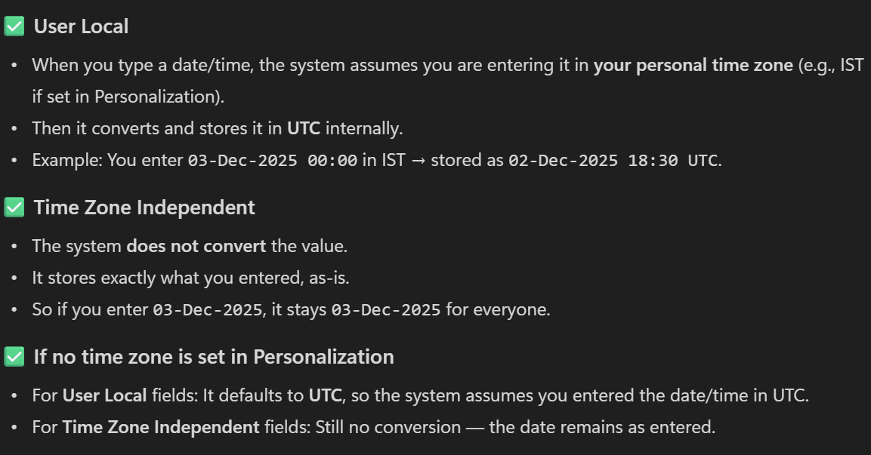

In User Local — Is the entered value and shown value same?
No. They are not the same.
In User Local behavior:
✔ The value you enter is converted to UTC and stored in the database.
✔ What CRM shows you later is converted back to your timezone.
So entered ≠ stored, but entered = shown only for the same user and only in the same timezone.

🔍 Example (Very Simple)
Your timezone: GMT+05:30 (India)
You enter: 10:00 AM
CRM stores in DB (UTC):
10:00 AM – 5 hours 30 min = 04:30 AM UTC
CRM shows back to you:
04:30 UTC + 5:30 = 10:00 AM
✔ Looks same to you
❌ But not same in backend

🔍 For another user in a different timezone
User in UK (GMT 0):
They will see: 04:30 AM

Conclusion:
User Local
- You enter: 10:00 AM
- CRM stores: 04:30 AM (UTC)
- You see again: 10:00 AM
- Other users see: Different time based on their timezone

. Time Zone Independent (Fixed, not converted)
📌 Meaning
The value is stored exactly as entered and shown the same to all users, regardless of timezone.
No UTC conversion.
✔ Example
Value entered: 10:00 AM
What all users see: 10:00 AM
(Does not matter if user is India, US, UK, Dubai)
🎯 Best for
- Business deadlines like 10 AM every day
- Schedules independent of geography
- Birthday, Anniversary time
- Cut-off times
- Local policies
- Regulatory time values

General setting
10 December 2025
16:43

- Auto save - system setting > general > Select the default save option for forms

1. Purpose
Calculated Field
- Performs real-time calculations using fields from the same record.
- Example:
Total Price = Quantity × Unit Price
Rollup Field
- Aggregates data from related child records or related entities.
- Example:
Total Opportunities Amount on Account = SUM(Opportunity Est. Revenue)

Business rule client side vs server side
22 January 2026
21:58

They can run in two locations:
- Client-side → runs in the browser (UCI form)
- Server-side → runs on the server (Dataverse backend)

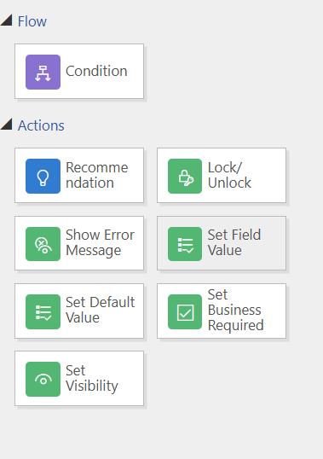

Entity Scope (Server-Side + Client-Side)
Meaning:
The rule runs at the entity level, not tied to any specific form.
✔ Where it runs:
- Works on All Forms
- Works on Quick Create Form
- Works on Mobile App
- Works on Web
- Works on Power Apps
- Works in Background (server-side) when record is created or updated via:
  - API
  - Workflow / Flow
  - Integration
  - Plugins
  - Editable Grid
✔ Example:
If business rule sets Field A = required,
even if record is created from API, it still becomes required.
🎯 Use when:
When the logic should apply everywhere, not just on the form.

🟢 2. All Forms Scope (Client-Side Only)
Meaning:
The rule runs only on the main forms of the entity.
✔ Where it runs:
- Only on Main Forms
- Only client-side (browser/UI)
- Does NOT run in:
  - Mobile app (unless form is shown)
  - API
  - Power Automate
  - Plugins
  - Quick Create Form
  - Editable Grid
  - Business process flow stage update
✔ Example:
If business rule hides a field,
it hides only when the user opens the form.
If record is created by API → rule does not run.
🎯 Use when:
When the logic is UI/UX specific, like:
- Show/hide fields
- Lock/unlock fields
- Form-only validation

Excel
22 January 2026
22:50

Can you explain the difference between a static and dynamic Excel export in D365
CRM?

--> 1. Static Excel Export
✔ Data is exported as of that moment

Static Excel means the file contains fixed data — basically a snapshot.
If the CRM data changes later, the Excel file does NOT update.

Dynamic Excel Export
✔ Excel file stays connected to CRM
Dynamic Excel is a “refreshable” Excel file.
It contains a connection back to the CRM system using OData/XML and can pull updated data when refreshed.

Solution
08 February 2026
16:53

- solution cloning
- Solution patching

1.Patching -
Only moving the particular component

-> solution->clone -> clone a patch

1.0.1.1 -> only allow to upagrade last two version number
Creates the copy of a solution

Original solution gets locked

Add the existing item in patch sollution that need to be updated
- Export and import

Clone solution
When you clone the original solution then the created patch solution will be merged
When updates are done completely then export and import the solution
While import
-upgrade the solution

In target environment instead of two environment there will be one environment

Solution layering -

Solution layering in Power Apps/Dynamics 365 determines which customization takes priority when the same component (form, field, view, BPF) exists in multiple solutions.
Layers stack like this (bottom → top):
1️⃣ System Layer (Microsoft default)
2️⃣ Managed Solution Layers (in order of import)
3️⃣ Unmanaged Layer (topmost)
👉 The topmost layer wins, but it overrides only the parts of the component it modifies, not everything.
The Unmanaged layer only overrides the specific parts it changes.
The rest of the Managed solution changes still remain.
This is where most people get confused.

🎯 Simple Real-Life Example (Very Easy)
Think of the Account Main Form as a page in CRM.
On this page, you have:
- Email field
- A new tab
- Header area
Now see what each solution is doing.

🟦 Managed Solution A
👉 Changes the Account form by hiding the Email field
So now Email field is NOT shown.

🟧 Managed Solution B
👉 Changes the Account form by adding a new tab
So now there is:
- Old tabs
- And one new tab

🟩 Unmanaged Customization
👉 Changes only the header colour of the form
(It does NOT touch Email field or the tab)

🟪 Final Output / What the User Sees
Because unmanaged is on top:
✔ Header color will change
(unmanaged modified this — so unmanaged wins)
✔ Email field will still be hidden
(unmanaged did NOT change email — so managed A’s change remains)
✔ New tab will still be visible
(unmanaged did NOT remove that tab — so managed B’s change remains)

✅ Simple Summary in One Line:
Unmanaged only overrides the things it changes.
All other managed changes still apply.

Solution versioning

-
Every solution has a version number in the format:
Major.Minor.Build.Revision

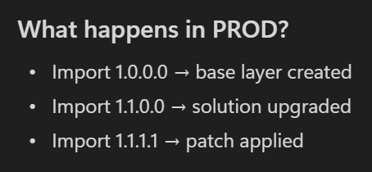

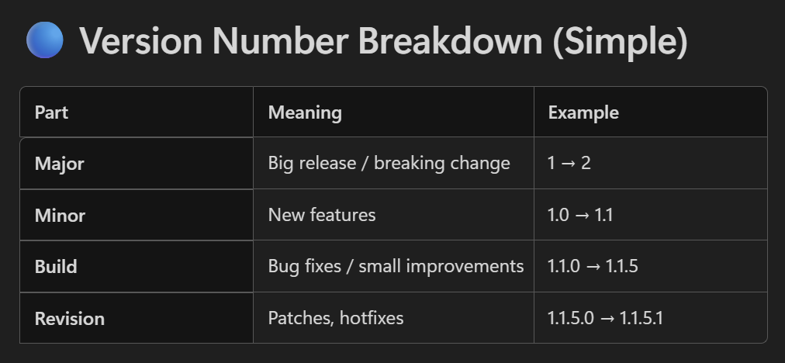
Your base solution version:
1.0.0.0
You add a new feature → update version to:
1.1.0.0
You fix a bug → update version to:
1.1.1.0
You release a small patch → version becomes:
1.1.1.1

Patches and Rollups (Very Short)
Patch
Small update, does NOT change major/minor.
Example:
1.1.0.0 → 1.1.0.1 (Patch)
Rollup (Upgrade)
Full upgrade.
Example:
1.1.0.1 → 1.2.0.0

Security Roles
08 February 2026
18:04

“A Business Unit is an organizational and security boundary in Dynamics 365 that controls data access. It segregates users/teams and determines what data they can view or modify based on their security role scope.”

Difference between owner team and access team
“Owner Teams can own records and have security roles, while Access Teams cannot own records and are used only to share access to specific records.”

1️⃣ Owner Teams
- Can own records
- Can have security roles
- All users inside the team get privileges from these security roles
- Very commonly used for:
  - Sharing records
  - Territory management
  - Department-level access
👉 User privileges = User roles + All owner team roles

2️⃣ Access Teams
- Cannot own records
- Do NOT have security roles
- Used only for record sharing
- Provide access, not roles
- Privileges depend on:
  - Access Team Template (Read, Write, Append, etc.)

Difference between append and append to

Append (Child/Child-side): The permission required to attach a record (e.g., a note) to a target record.
Append To (Parent/Parent-side): The permission required for a record (e.g., an account) to have another record attached to it.

Field level security
08 February 2026
18:24

How to Configure Field-Level Security in Dynamics 365 CRM
Field-level security is configured in three steps:

Field-Level Security (FLS) in Dynamics 365 CRM is a security feature that allows organizations to restrict access to specific fields (columns) on a table (entity).

⭐ Step 1: Enable Field Security on the Field
- Go to Maker Portal → Tables
- Select your table (e.g., Contact, Account)
- Go to Columns
- Choose the field you want to secure
- Set Field Security = Enabled
- Save & Publish
📌 Once enabled, all users lose access until you assign access via a profile.

⭐ Step 2: Create a Field Security Profile
- Go to Advanced Settings
- Navigate to:
Settings → Security → Field Security Profiles
- Click New
- Give the profile a name (e.g., HR Profile, Finance Restricted)
- Save the profile

⭐ Step 3: Add Permissions for Secured Fields
Inside your Field Security Profile:
- Open the profile
- Go to Field Permissions tab
- Click the secured field
- Set:
  - Read → Yes/No
  - Update → Yes/No
  - Create → Yes/No
- Save & Publish

⭐ Step 4: Add Users or Teams to the Profile
Inside the same profile:
- Open the profile
- Go to:
  - Users sub-grid → Add users
  - or Teams sub-grid → Add teams
- Save
👉 Whoever is added here gets access to those field permissions.

Ribbon Work bench
08 February 2026
20:17

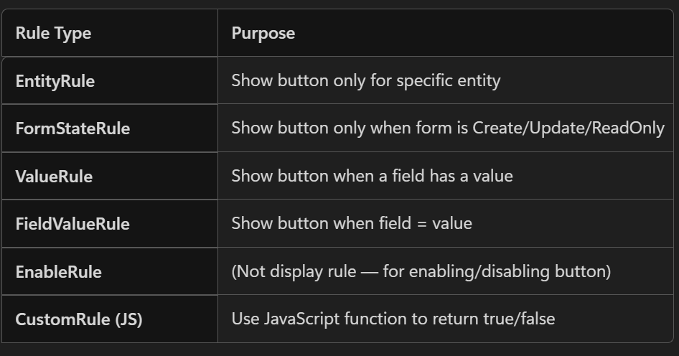

Types of grid -

Main form grid
Main grid
Associated grid
subgrid

Size of ribbon button
. Small Icon (Web Application / Grid / Lookup)
- Size: 16 × 16 px
- Formats: .png, .gif, .jpg
- Max Size: Less than 10 KB
[learn.microsoft.com]
This icon appears in:
- Views (grid rows)
- Lookup fields
- Subgrids

2. Medium Icon (Entity Form)
- Size: 32 × 32 px
- Formats: .png, .gif, .jpg
- Max Size: < 10 KB
[learn.microsoft.com]
This icon appears on:
- The form header
- Sitemap area (in some UI layouts)

3. Large Icon (Rarely used)
- Size: 66 × 48 px
- Max Size: < 10 KB
[learn.microsoft.com]

Data import
08 February 2026
22:58
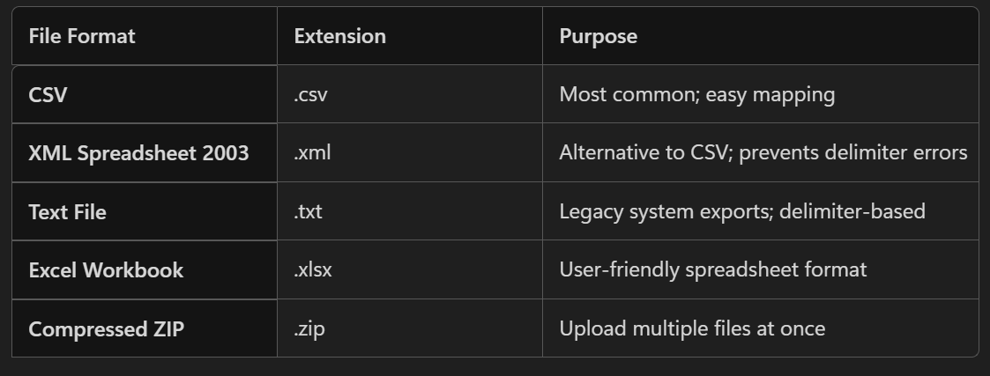
Supported files to import

Export
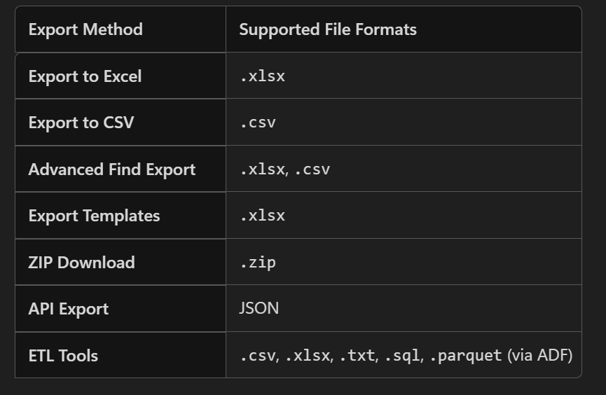

Security Roles
27 August 2025
14:25
Access of security roles to the user even if having the system administrator and system customizer role.
Restrictions -->
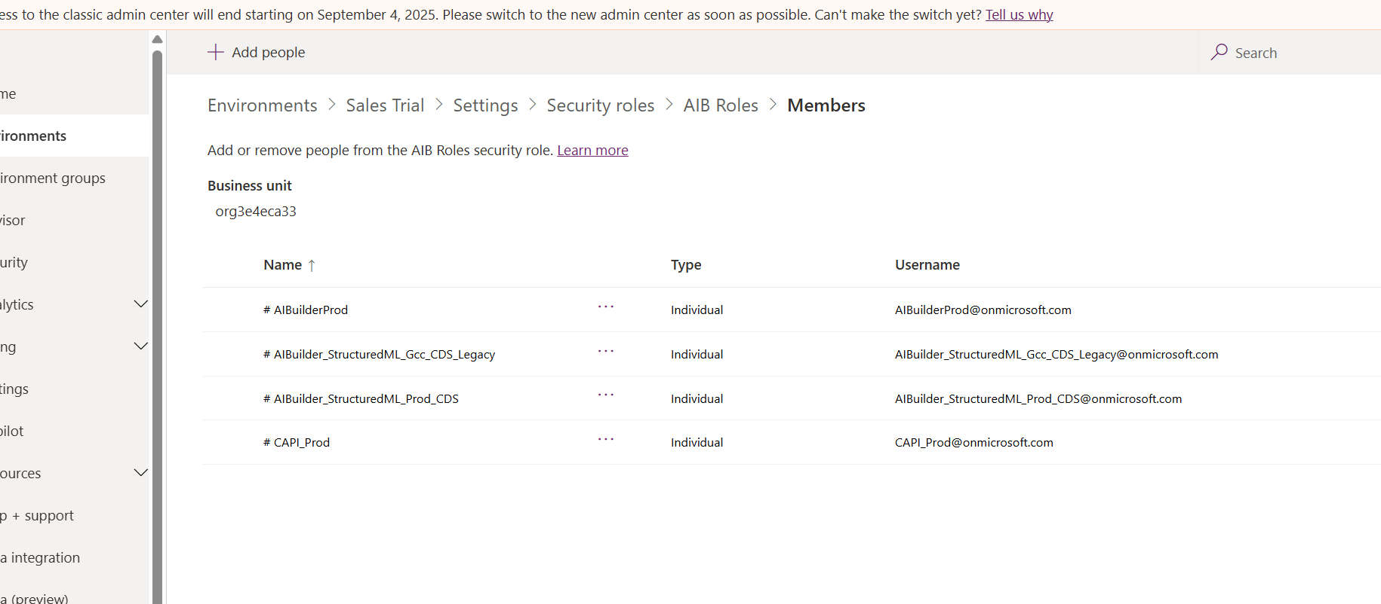

2.business unit restriction-

Security Roles Are Scoped to Business Units
Each security role is created within a specific business unit.
You can only see and assign roles that belong to your own business unit or its child units.
If you're in a different business unit than the role, it may not appear in your list—even with admin privileges.

PL -200 Notes

Function Certf. PL-200
17 September 2025
11:46
- Dataverse automatically generates the GUID when a new row is created.

- 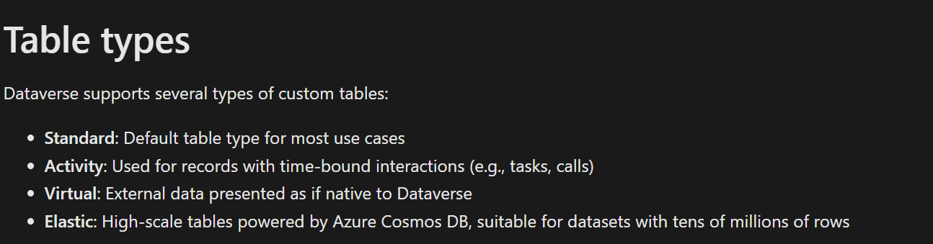

Virtual Tables :
Description: These tables provide a way to access data residing in an external data source (like a SQL database) without duplicating the data within Dataverse.
Examples: A virtual table could display data from an Azure SQL Database or another external system.
Use Case: Integrating external data into your Dynamics 365 interface for read-only purposes.

Table types are set during creation and can't be changed later.

- Many - Many relationship in msd 365 crm :
- One-to-many (1:N) table relationships establish a hierarchy between rows. With many-to-many (N:N) relationships, there's no explicit hierarchy. There are no lookup columns or behaviors to configure.

- Users must be assigned at least one security role to access Dataverse and run apps.
- If a column type needs to be changed to a different column type, (i.e. text column to a choice), then you will need to delete the column and recreate with the correct column type. Doing this will cause you to lose all the data in the column.

How to make default form in app :

Form >Form setting >Form order>choose a form set>select form

Resources
28 September 2025
19:19

Top Resources for PL-200 Functional Certification Questions
Microsoft Learn – Official Study Guide

Covers all skills measured in the PL-200 exam.
Includes links to learning paths and documentation.
🔗 Microsoft Learn PL-200 Study Guide 1
ITExams – Free Practice Questions
-https://learn.microsoft.com/en-us/credentials/certifications/resources/study-guides/pl-200

Offers over 300 questions with detailed scenarios.
Includes HOTSPOT and multiple-choice questions.
Useful for practicing real-world use cases involving choice columns.
🔗 ITExams PL-200 Practice Questions 2
CertSteps – Free Questions and Case Studies
- https://www.itexams.com/exam/PL-200/1

Includes case study-based questions and HOTSPOT formats.
Covers topics like form controls, data sources, and portal configuration.
🔗 CertSteps PL-200 Questions 3
Quizlet – Flashcards for PL-200
- https://www.certsteps.com/exams/microsoft/pl-200/test/

Interactive flashcards for quick revision.
Includes questions on Power Automate, canvas apps, and Dataverse.
🔗 Quizlet PL-200 Flashcards 4
ExamTopics – Community-Driven Questions
- https://quizlet.com/813322012/pl-200-functional-consultant-associate-practice-exam-flash-cards/

Large question bank with community discussions.
Frequently updated with real exam feedback.
🔗 ExamTopics PL-2005
ExamLabs – Free Sample Questions
- https://www.examtopics.com/exams/microsoft/pl-200/

Offers 25 updated sample questions.
Focuses on Dataverse, PowerApps, and Power Automate.
🔗 ExamLabs PL-200 Sample Questions 6

- https://www.examlabs.com/certification/complimentary-sample-questions-for-microsoft-power-platform-functional-consultant-pl-200-certification/

Choice Column
28 September 2025
19:39

  - Choice column
  - Data Type - Two types - Choice and Yes/No => Behaviour -simple / calculated
  - You shouldn't use choices when the column usually contains unique entries that aren't easily standardized, but you should use them when you want specific data entry categorization.

  - Case Priority (Choice Column)
Choices:
High
Medium
Low

  - Customer Email (Text Column)
This should not be a choice column because each customer has a unique email address

  - We can make columns of type choice business required when they're created or edited.
  - Choice columns are also known as picklists and option sets.
Choices are key/value pairs contain items with an integer value and a label. The integer value is stored in the column in the row and the label is stored in metadata. Labels in choices are supported for localization and you can specify the labels for the different languages enabled in the environment.
  - Microsoft Dataverse includes over 100 standard choices that are created each time that you instantiate a new instance of a Dataverse datastore. You can add to a standard choice, but you can't delete an entry from a standard choice.
  - standard choices are global choices that you can use when creating a choice column for a table

  - Which of the following can choices contain?
Ans -Numbers or Text

  - What type of choice can only be used by the table and column that they are created against?
Ans - Local choices

  - You want to filter a view based on a specific choice value. What must be true?
A. The column must be a global choice
B. The column must be searchable
C. The column must be indexed
D. The column must be a lookup
✅ Correct: B

  - Which Power Apps formula retrieves the selected value from a choice column?
A. Dropdown.Selected.Value
B. ComboBox.SelectedItems
C. ChoiceColumn.Value
D. SelectedChoice.Text
✅ Correct: A

  - You need to filter records based on a choice column in Power Automate. What should you use?
A. OData filter with integer value
B. OData filter with label
C. Contains expression
D. Lookup filter
✅ Correct: A

Q. Which expression retrieves the label of a choice column in Power Automate?
A. outputs('Get_row')?['ChoiceColumn']
B. outputs('Get_row')?['ChoiceColumn@OData.Community.Display.V1.FormattedValue']
✅ Correct: B

  - Which tool allows you to migrate choice column values between environments?
A. Configuration Migration Tool
B. Solution Importer
C. Package Deployer
D. Data Export Service
✅ Correct: A

  - You need to localize choice column labels for multiple languages. What should you configure?
A. Language Packs
B. Column Translations
C. PCF Controls
D. Business Rules
✅ Correct: B

  - Which limitation applies to multi-select choice columns in Dataverse?
A. Cannot be used in views
B. Cannot be filtered in Power Automate
C. Cannot be used in calculated fields
D. Cannot be displayed in model-driven apps
✅ Correct: C

  - You want to audit changes to a choice column. What should you enable?
A. Column-level auditing
B. Table-level auditing
C. Business rule logging
D. Power Automate logging
✅ Correct: A

Relationships
29 September 2025
10:53

- most common Relationships are one-to-many and many-to-many

- The many-to-many relationship (which is also called N:N) includes a special third table called a relationship table, sometimes called an intersect table, which maps how the many rows of one table can be related to the many rows of another table.

- -Mapping - Only apply to one-to-many relationships.

Edit or delete the relationship
-The only columns you can edit are the Lookup column display name ,Lookup column description , Lookup coloumn requirement as needed

- Intersection table in Many to many relationship table
- The intersect table is not visible to users. More importantly, you cannot add columns to the intersect table or trigger workflow or Power Automate cloud flows when rows are associated, or disassociated, with each other.

Suppose you want to send an email to a contact when they are added to an event.
You might think:

“I’ll create a Power Automate flow that triggers when a row is created in the intersect table.”

But here’s the problem:

The intersect table is hidden from the UI and Power Automate.
You cannot select it as a trigger in Power Automate.
You cannot add custom columns to store metadata like registration date.
You cannot trigger a flow when a contact is associated or disassociated with an event.

- Not all tables can be used with many-to-many relationships. If the table is not listed in the designer, you cannot create a new many-to-many relationship with this table.
- You cannot edit the tables in a many-to-many relationship after it has been created; you can only delete it.

- You need to trigger a flow when a record is associated via a many-to-many relationship. What should you do?
- Plugin- The Associate message is fired when two records are linked via a many-to-many relationship.

- Why Power Automate Alone Won’t Work:
Intersect tables (used for many-to-many relationships) are not exposed in Power Automate.
You cannot directly trigger a cloud flow when a record is associated or disassociated via these tables
- Refer this website for triggering the power automate flow using in many to many relationship -https://www.thetindog.com/dynamics-as-we-go/how-to-use-power-automate-with-many-to-many-relationship-triggers

- What is a limitation of using the intersect table in this scenario?
A. You can only trigger flows when the course is updated.
B. You cannot add custom columns or trigger flows directly on the intersect table.
C. You can only use classic workflows, not cloud flows.
D. You must use a one-to-many relationship instead.
✅ Correct Answer: B

- Which of the following is true about intersect tables in Dataverse?
A. You can add custom columns
B. You can trigger Power Automate flows directly
C. You can view them in model-driven apps
D. They are system-managed and hidden
✅ Correct: D

- You want to prevent duplicate contacts during data import. What should you configure?
A. Business rule
B. Duplicate detection rule
C. Plugin
D. Power Automate flow
✅ Correct: B

- You need to trigger a flow when a record is associated via a many-to-many relationship. What should you do?
A. Use a cloud flow on the intersect table
B. Use a plugin on the Associate message
C. Use a business rule
D. Use a calculated column
✅ Correct: B

Rollup
29 September 2025
19:07

- When you configure a rollup column, Dataverse starts two recurring jobs.
- These two jobs are a Mass calculate rollup and a Calculate rollup.
-You must define a relationship of one from this table to many for another table or the ability to define a rollup will not be available.

- following column types support rollups:

- Whole number

- Decimal number

- Currency

- Date and time

Two other fields are created on create of a rollup coloumn- test field

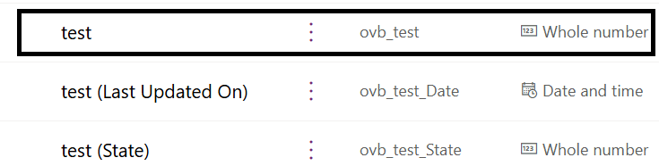

- The key considerations about rollups are as follows:

- When you specify the column and select a supported column type, you can define the rollup calculation.

- Rollups calculate a value from a column in one or many child rows in a related table.

- You're limited to a maximum of 10 rollups for each parent table.

- Rollup columns are read-only.

- Because rollup columns persist in the database, they can be used for filtering or sorting just like regular columns.

- Remember that rollups are asynchronous and are calculated by Dataverse on a set schedule, so you might not see the expected value in a rollup until that job runs.

The job is automatically created when the first rollup column on a table is created and deleted when the last rollup column is deleted.
The maximum hierarchy depth is limited to 10 for the source row.
The maximum number of rows during the rollup refresh is limited to 50,000 rows. In case of the hierarchical rollup, this applies to the related rows across the hierarchy

- Power Fx formula columns
-Formula columns use the Power Fx language to calculate the value for the column. Formula columns are read-only.

The following data types are supported in formulas:

Single line of text

Decimal number

Date and time

Yes/no

Security Roles
30 September 2025
11:26
- A user is automatically associated with the Environment Maker role when they are added to an environment.
- Users who make apps that connect to Dataverse and need to create or update table and security roles need to be assigned the System Customizer role in addition to the Environment Maker role. This is necessary because the Environment Maker role doesn't have privileges on the environment's data.
- Roles are groups of permissions that you assign to a user.
- Append - Required to associate the current record with another record; for example, if a user has Append rights on a note, the user can add a note to an opportunity. In many-to-many relationships, you must have Append privilege for both tables being associated or disassociated.
- Append - Required to associate the current record with another record; for example, if a user has Append rights on a note, the user can add a note to an opportunity. In many-to-many relationships, you must have Append privilege for both tables being associated or disassociated.
- Append To - Required to associate a record with the current record; for example, if users have Append To rights on an opportunity, they can add a note to the opportunity.
- Tables that are organization owned do not have the Assign or Share privileges.

Append and Append to
- Append and Append To permissions are complementing each other. If parent entity do not have Append To permission and child entity do not have Append permission then the look up field will not be enabled.

- Tables that are organization owned only use the None or Organization access levels.

- Miscellaneous privileges
- Bulk Edit

- Merge

- Export Customizations

- Import Customizations

- View Audit History

- Privacy related privileges -

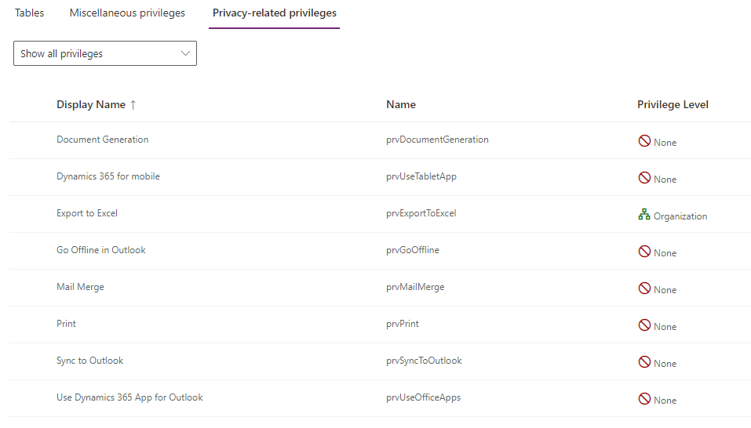

- Although a team belongs to one business unit, it can include users from other business units. You can associate a user with more than one team.

- Owner team: an owner team owns records and has security roles assigned to the team. A user's privileges can come from their individual security roles, those of the teams that they're part of or the ones they inherit. A team has full access rights on the records that the team owns. Team members are added manually to the owner team.

- Access team: an access team doesn't own records and doesn't have security roles assigned to the team. The team members have privileges defined by their individual security roles and by roles from the teams they're members of. These members share records with an access team, and the team is granted access rights to the records. Access rights include Read, Write, and Append.

- Microsoft Entra ID group team: Similar to owner teams, a Microsoft Entra ID group team can own records and can have security roles assigned to the team. Security and Office are two group team types, and they correspond directly to Microsoft Entra ID group types. Group security roles can be assigned only for a specific team or for a team member with user privileges that include members' privilege inheritance. Team members are dynamically derived (added and removed) when they access an environment based on their Microsoft Entra ID group membership.

- Dataverse Group Teams & Microsoft Entra ID Integration – Summary

- Group Teams in Dataverse can be linked to Microsoft Entra ID groups (Security or Microsoft 365).
- These teams can own records and be assigned security roles.
- Team members are dynamically managed based on their Entra ID group membership.
- Security roles can be assigned to the group team, granting access to all members.
- Supports Assigned and Dynamic User membership types (not Dynamic Device).
- No need to assign roles individually—just add users to the right Entra ID group.
- When users are removed or disabled, access is revoked automatically at runtime.
- Teams can own records, and members can act with User-level privileges if the role allows member’s privilege inheritance.
- Useful for sharing Power Apps, securing environment access, and simplifying user provisioning.

Administration
01 October 2025
16:35

- Audating -
- Enabling and disabling of auditing can only be done by someone in the System Administrator or System Customizer role.
- Bulk delete-
- Microsoft Dataverse includes basic bulk row deletion functionality. The purpose of bulk delete is to remove stale data and manage the consumption of system storage by deleting data that you no longer need.
- Data deleted by bulk delete jobs cannot be recovered.

- Dataverse long term data retention requires a Managed environment.

- Data Retention -
- In Microsoft Dynamics 365 CRM, data retention policies are designed to help organizations manage the lifecycle of their data — from active use to long-term storage and eventual deletion — while ensuring compliance, performance, and cost-efficiency.

- What Are Data Retention Policies?
Data retention policies define:

How long data is kept
Where it is stored
When it should be archived or deleted

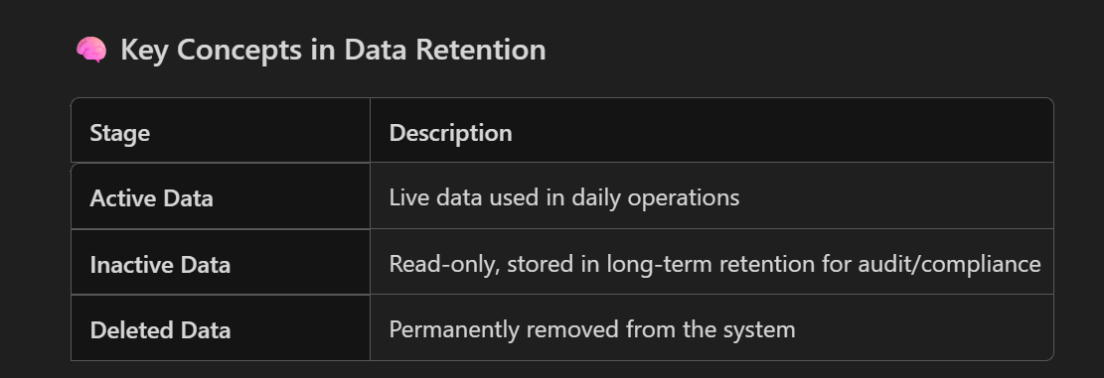

- Enable retention policy at table level
- Create the data retention policy in power apps maker portal in retention policies in power apps
- To view retained data you require organizational access level read privilege on the table.

Charts
03 October 2025
15:05
Types of charts
- System charts - availaible to all user -maintained by system customizer or system administrator
- Personal charts - specific - can be shared with other users

🔹 System Charts

Created by: System administrators or customizers.
Visibility: Available to all users in the organization.
Stored in: The solution layer, meaning they can be exported/imported as part of a solution.
Security Role Required: You need appropriate privileges (like customization rights) to create or modify system charts.
Use Case: Ideal for organization-wide reporting and dashboards.

🔹 Personal Charts

Created by: Individual users.
Visibility: Only visible to the user who created them, unless shared manually.
Stored in: User’s personal settings, not part of the solution.
Security Role Required: No special privileges needed; any user can create them.
Use Case: Useful for personalized views or temporary analysis.

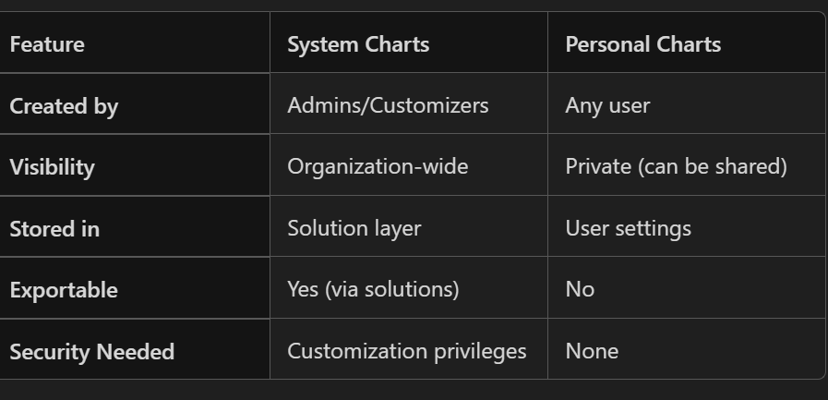

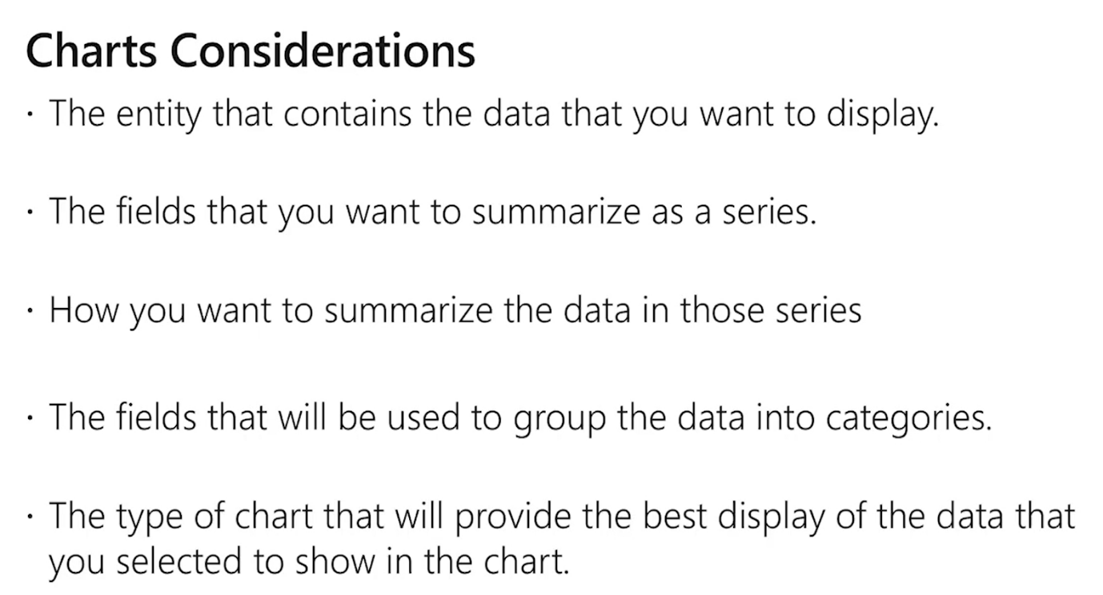

-charts are created using the chart designer tool

You cannot configure the following -
1. Views that charts will represent visually
- ✅ Configurable in Personal Charts: When creating a personal chart, you can choose the view (e.g., "My Active Contacts") that the chart is based on.
- ❌ Not directly configurable in System Charts: System charts are tied to specific views defined in the chart XML. You can't dynamically change the view unless you edit the chart XML or recreate the chart.

2. Records that charts will include
- ✅ Configurable via Views: The records shown in a chart depend on the underlying view. You can filter records in the view, and the chart will reflect those.
- ❌ Not configurable within the chart itself: You can't filter records directly inside the chart; you must do it through the view.

3. Colours
- ❌ Not configurable via UI: Dynamics 365 does not allow users to change chart colors through the standard UI.
- ✅ Configurable via XML customization: For System Charts, you can export the chart XML and manually define colors using <Color> tags.

Chart Types in MSD 365 CRM
- Column Chart
  - Displays data as vertical bars.
  - Good for comparing values across categories.
- Bar Chart
  - Displays data as horizontal bars.
  - Useful when category names are long or when comparing many items.
- Pie Chart
  - Shows proportions of a whole.
  - Best for showing percentage distribution.
- Line Chart
  - Displays trends over time.
  - Ideal for time-series data like sales over months.
- Area Chart
  - Similar to line chart but with filled areas.
  - Highlights volume under the curve.
- Funnel Chart
  - Represents stages in a process (e.g., sales pipeline).
  - Useful for tracking conversion rates.
- Multi-Series Chart
  - Combines multiple data series in one chart.
  - Can be column, bar, or line format.
- Stacked Chart (Column or Bar)
  - Stacks multiple series in one bar/column.
  - Useful for showing part-to-whole relationships.

Power FX
03 October 2025
15:31

-There are two places you can use Power Fx when customizing a command:

OnSelect - This logic executes when a command button is selected by a user.

Visible - This logic is executed to evaluate if the command should be hidden or visible to the user running the app

Command bar
03 October 2025
15:45

Currently active data-
- The ability to reference currently active data is a valuable feature when writing formulas for commands. For example, if the command bar is on the main form for a table row the current active data is the row.
- If the command bar is on the main grid, then the current active data is the table of rows displayed on the grid.

Ribbon Workbench -
Three types of ribbons
  - Home
  - Sub grid
  - Form
Types of Buttons –
1. Button – A normal button
2. Split button – multiple buttons inside the button
3. Flyout
4. Menu Section – It is not a button but the section inside the multiple buttons can be added. This menu section can be added inside the split button and flyout button
5. Group – Group of buttons
- Flyout Button
A flyout button is a single button which, when clicked, opens a menu (flyout) containing multiple sub-buttons.
✔️ Key Characteristics

Acts like a dropdown menu.
The main button does NOT execute any command.
Only the sub-buttons inside the flyout execute commands.
Good for grouping related actions under one parent button.

✔️ Example
“More Actions” button which opens options like:
Assign
Share
Run Workflow

2️⃣ Split Button
A split button has two clickable areas:

Left side → executes primary action.
Right side → shows a dropdown with additional actions.

✔️ Key Characteristics

Main (left) part executes default command.
Arrow (right) part opens additional commands.
Good when you want one main action, plus optional actions.

✔️ Example
A "Convert" button
Click main icon → Convert to Case
Click arrow →
Convert to Lead
Convert to Opportunity

- Commands –
Commands tell CRM what action to perform when a button is clicked.
1. JavaScript Command
2. URL Command (Open URL Action)
- Add the address
- and the parameters to the url action if there is any custom webpage or parameters needs to be passed
3. Open Entity Form Command -Used to open:
- A specific form
- Quick create form
- New record form

4. Run Workflow Command -Used to run on-demand workflows

Types of images -
1. Image 16 – classic ui
2. Image 32 – classic ui
3. Modern image -Vector format for modern ui

Custom Api

Questions
16 October 2025
14:44

You are developing an automated cloud flow for a Microsoft Dataverse Contacts table. The cloud flow should start when a new contact is added to the table.
You need to fetch attributes from the header of the trigger in the actions.
Which expression function should you use?

- triggerFormDataValue()

- triggerBody()

- triggerOutputs() -correct

- result()

Ans-
- triggerBody() is used to access attributes directly from the body of the trigger output, while triggerOutputs() returns the entire trigger output, which includes the body, headers, and other metadata
- triggerFormDataValue() function is used to return a single value matching a key name in form-data or form-encoded trigger outputs.

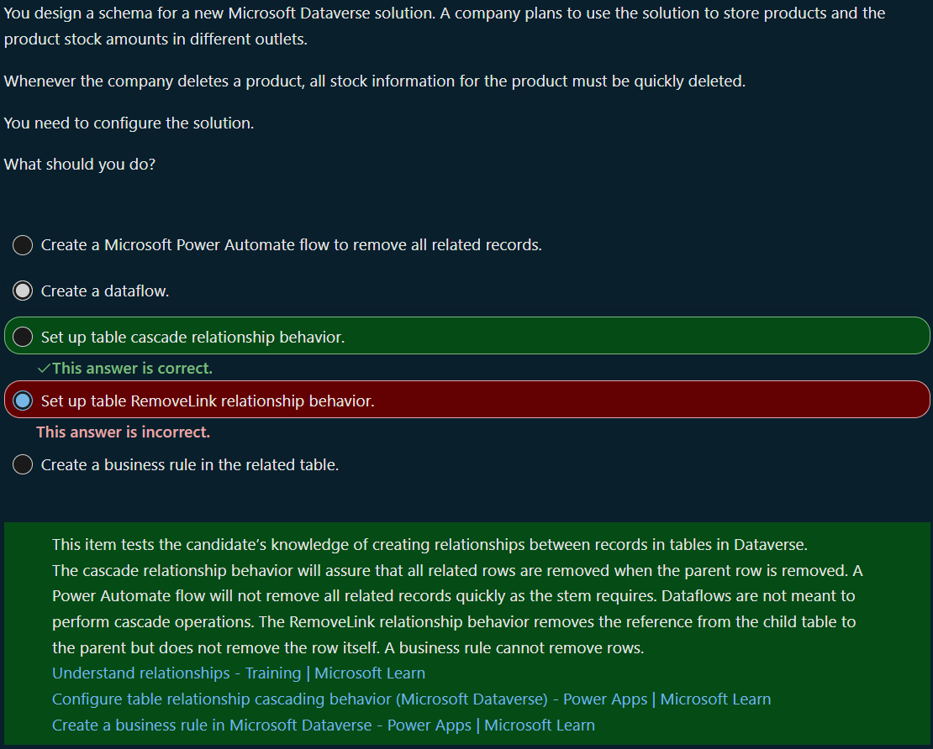

3.
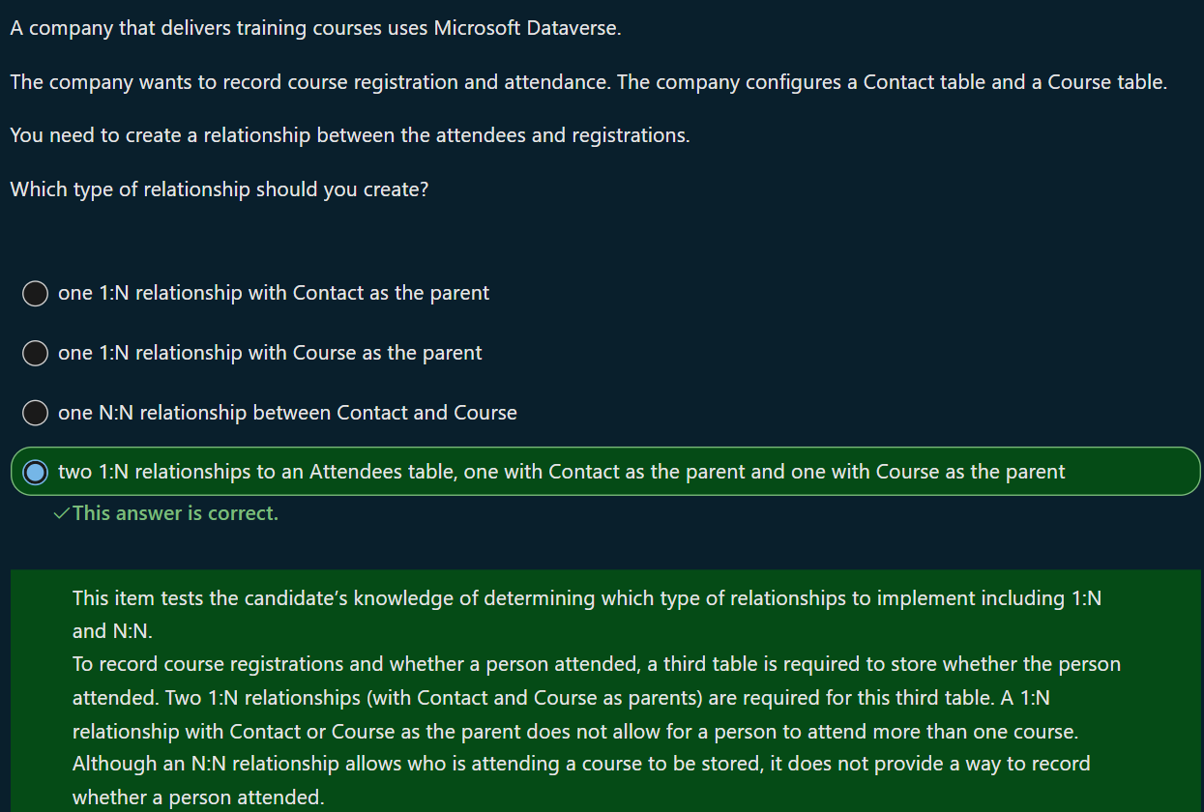

4 .
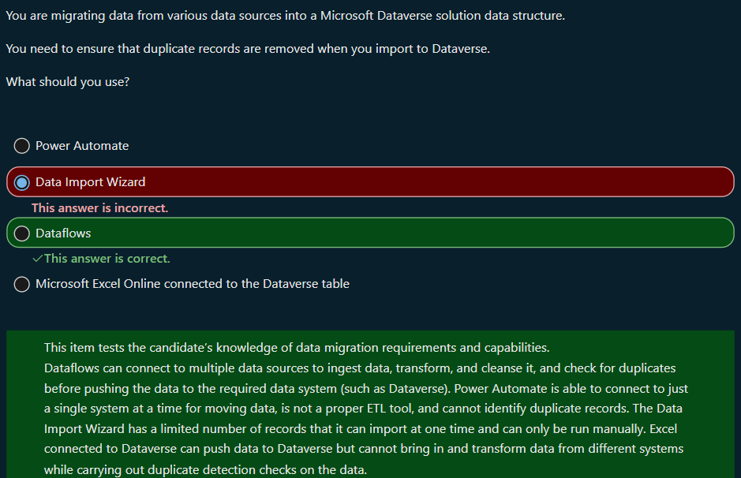

5.
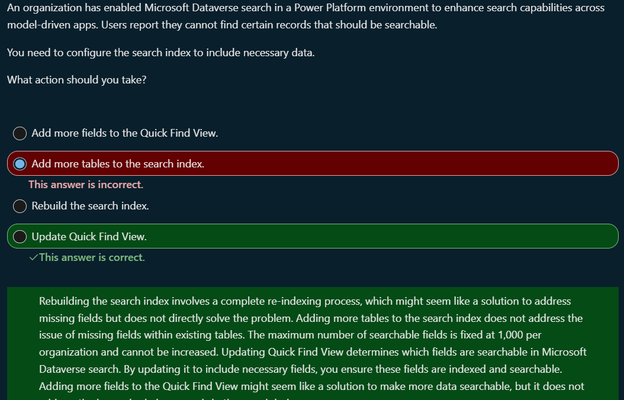

6.
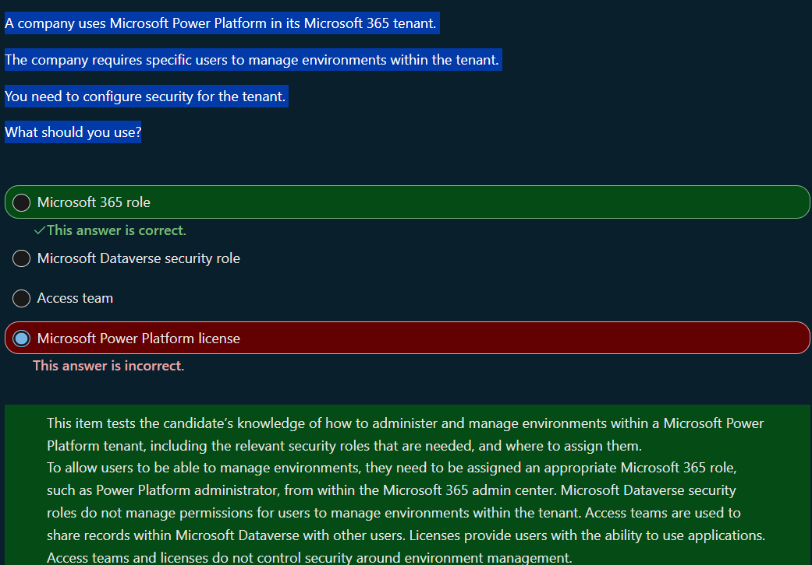

7.
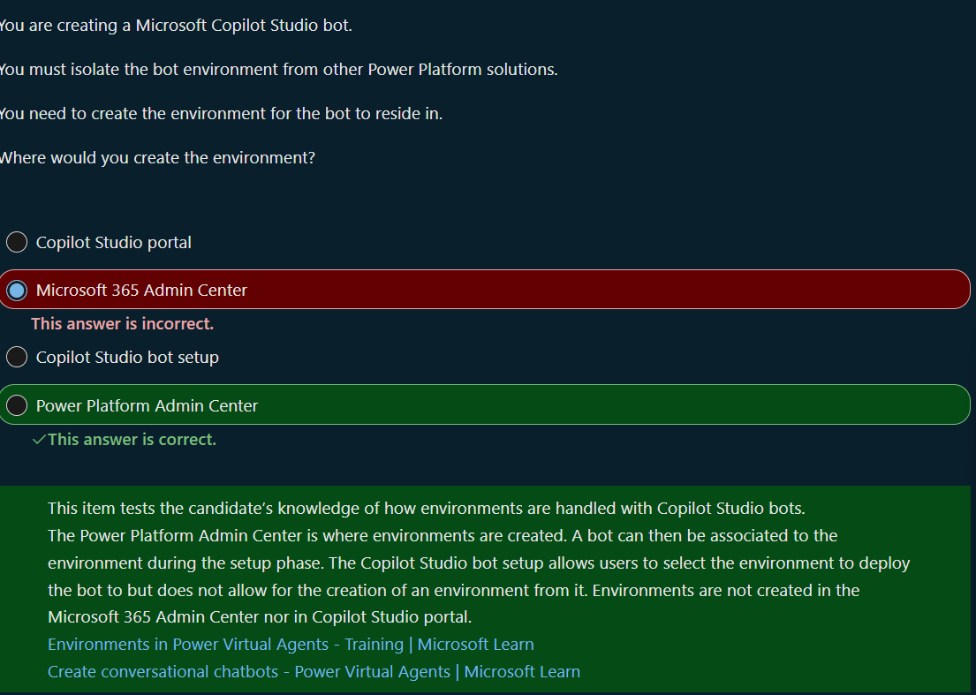

8.
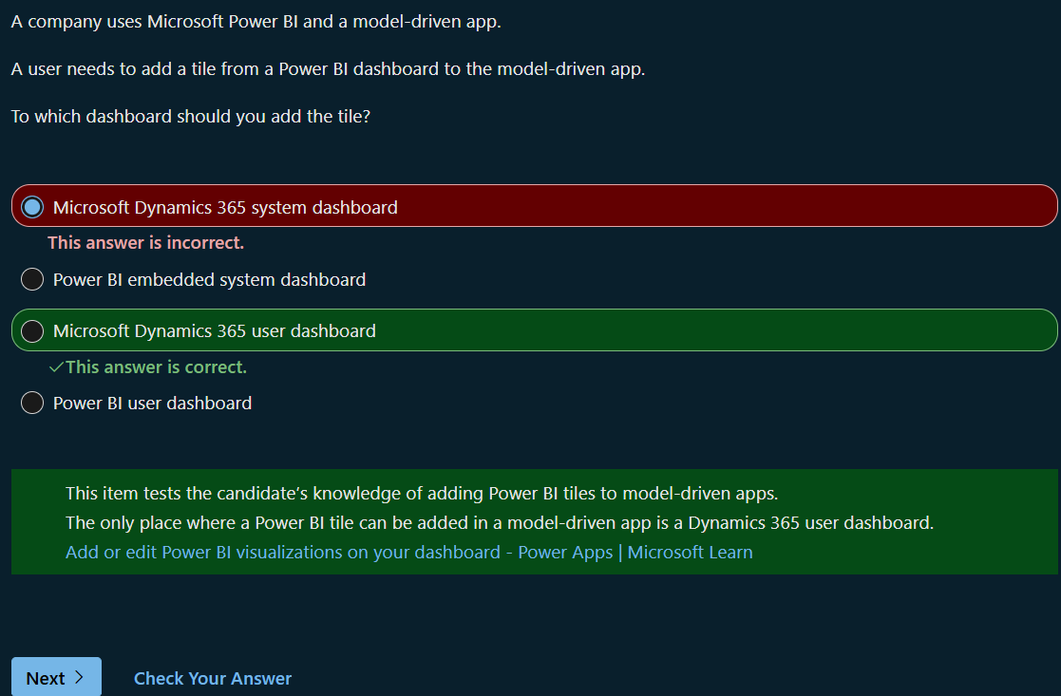

9.
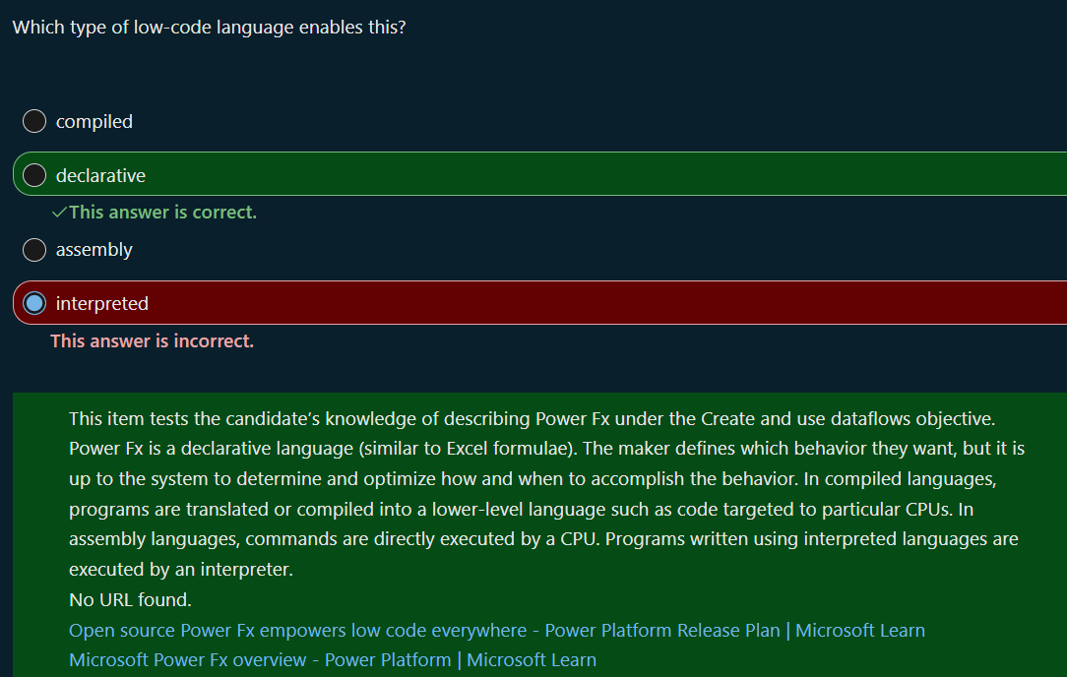

10.
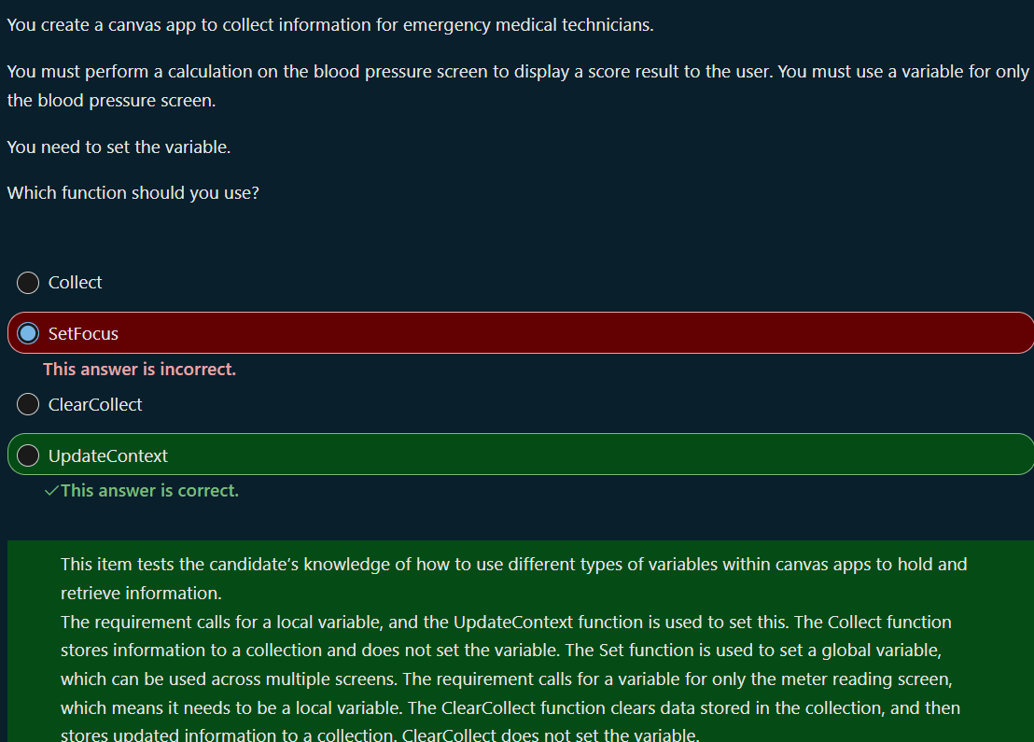

10.
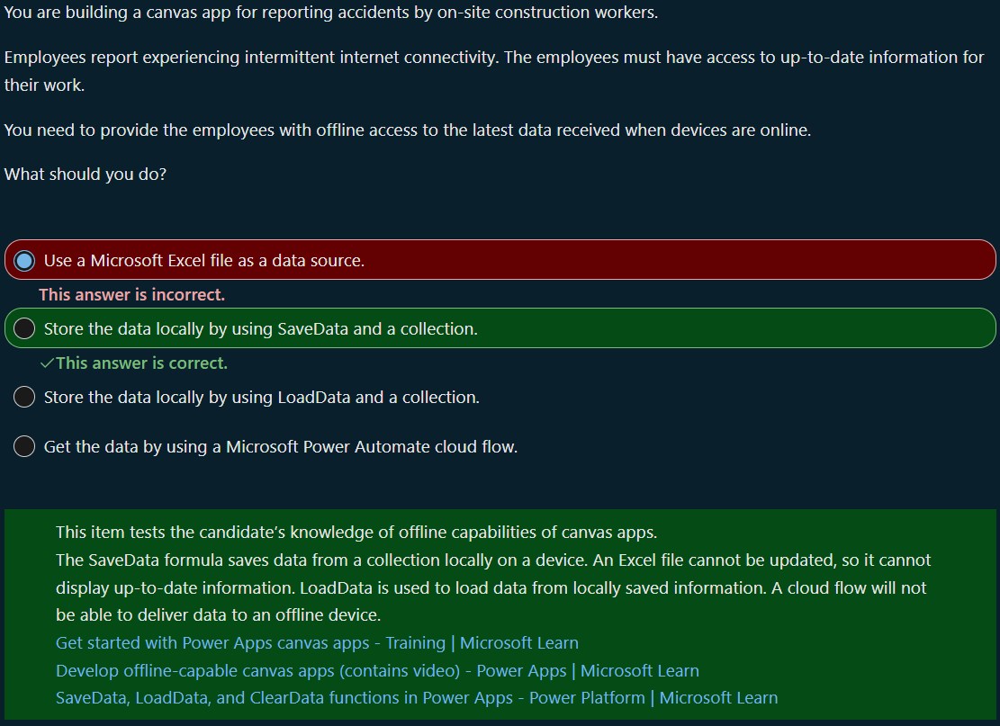

11.
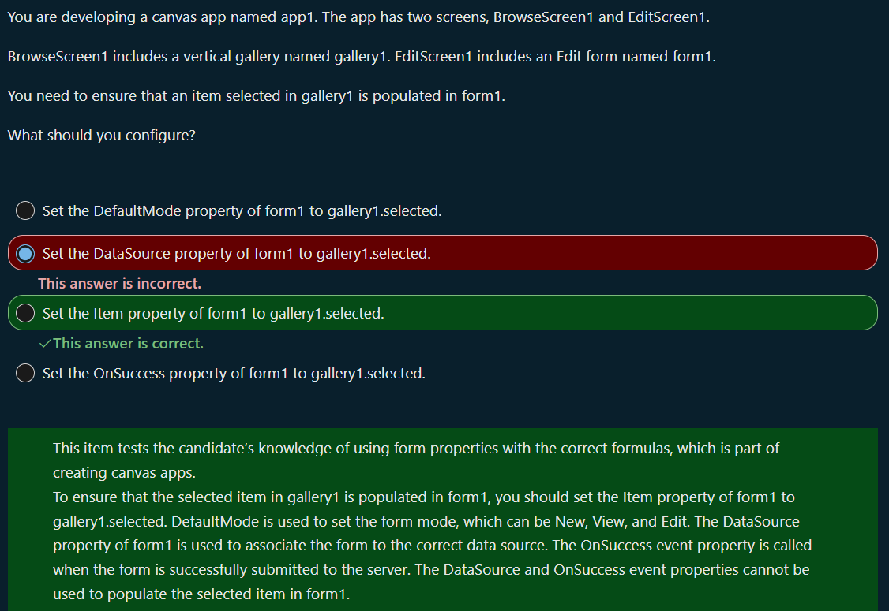

12.
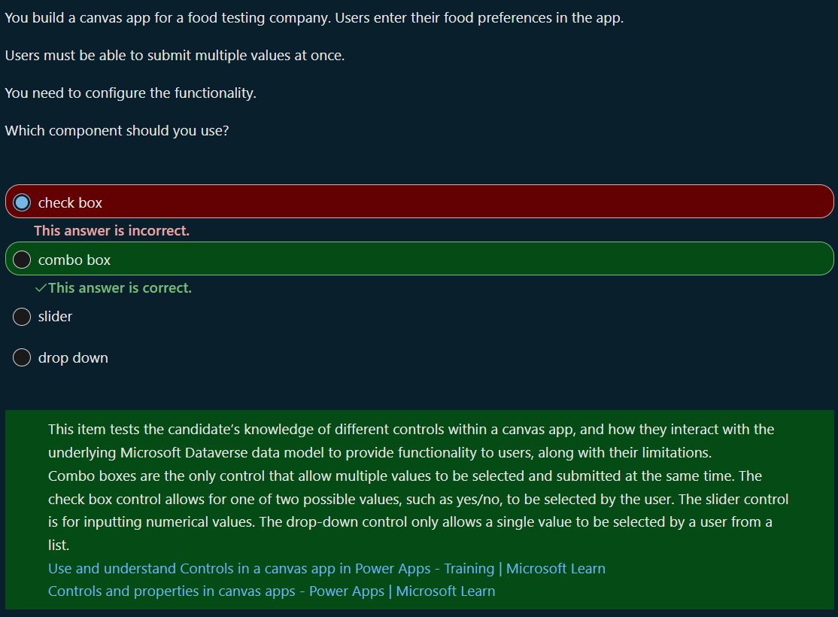

13.
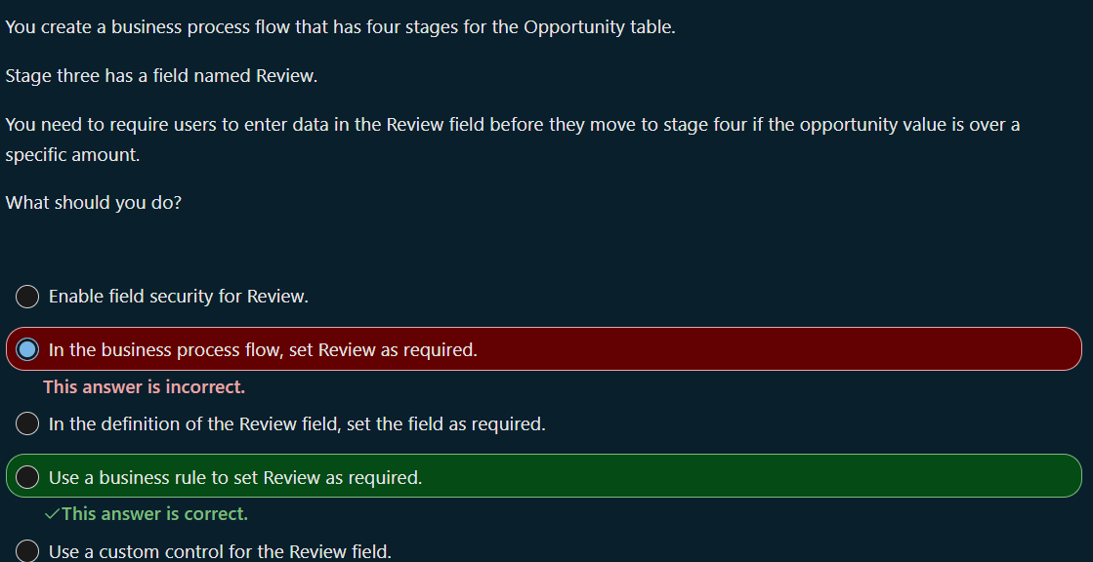

14.
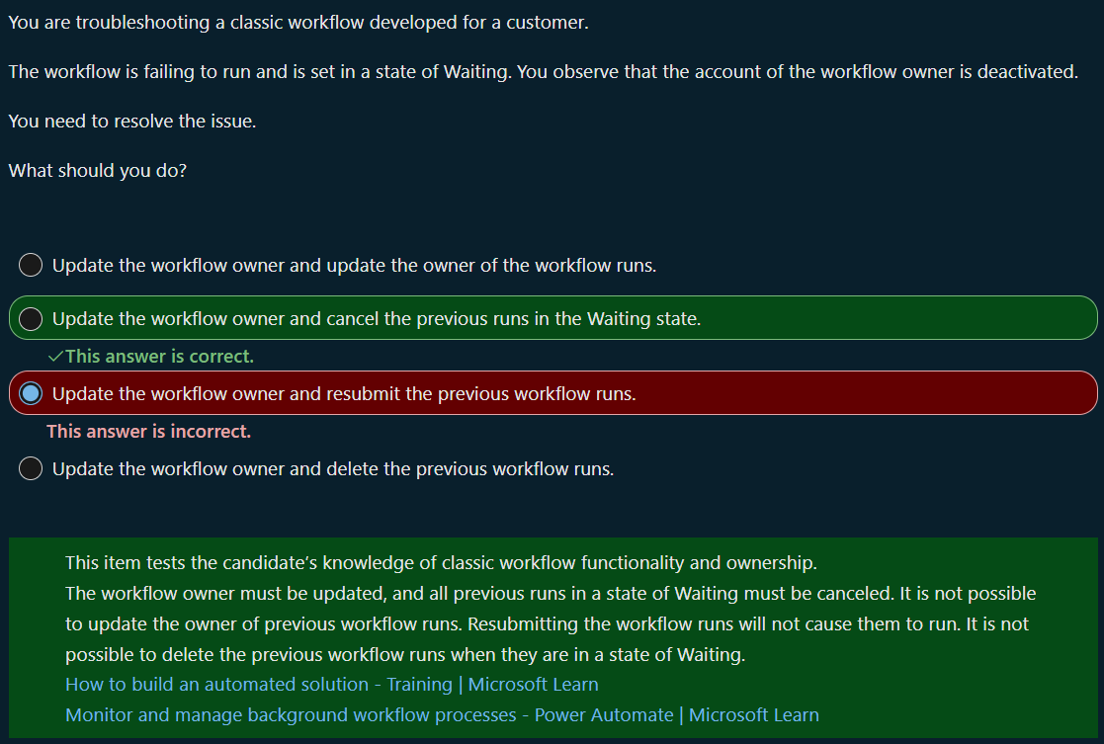
15.
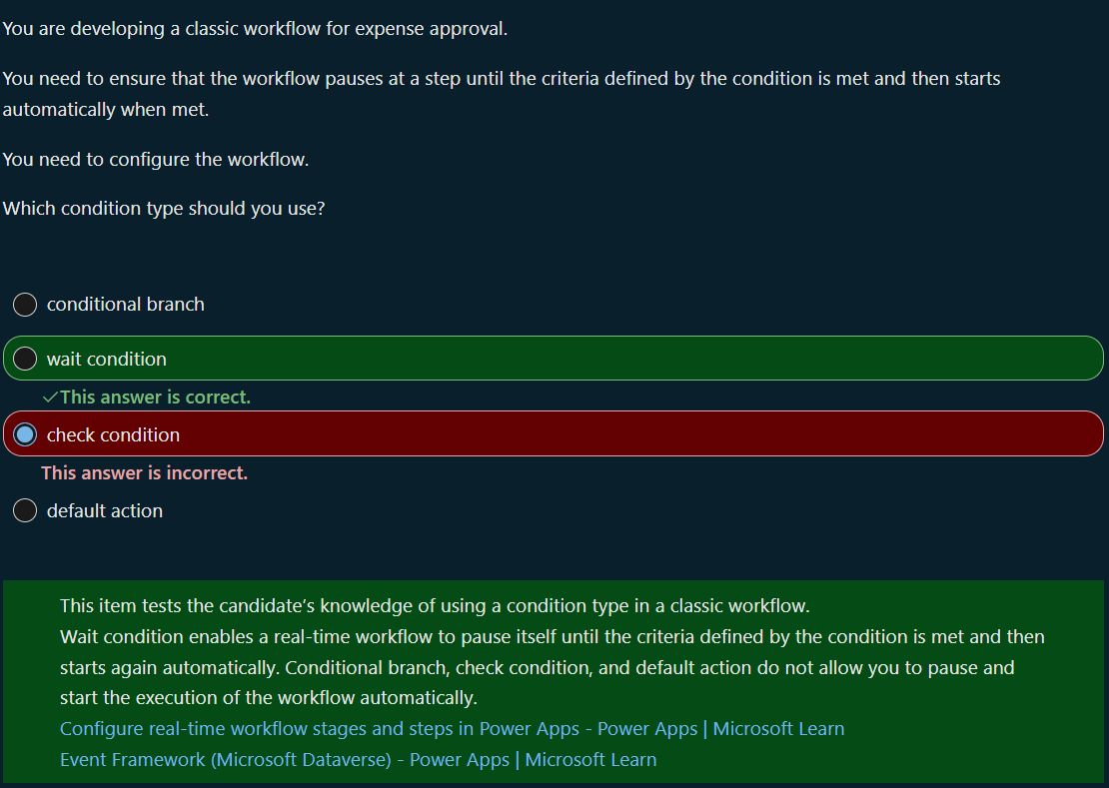
16.
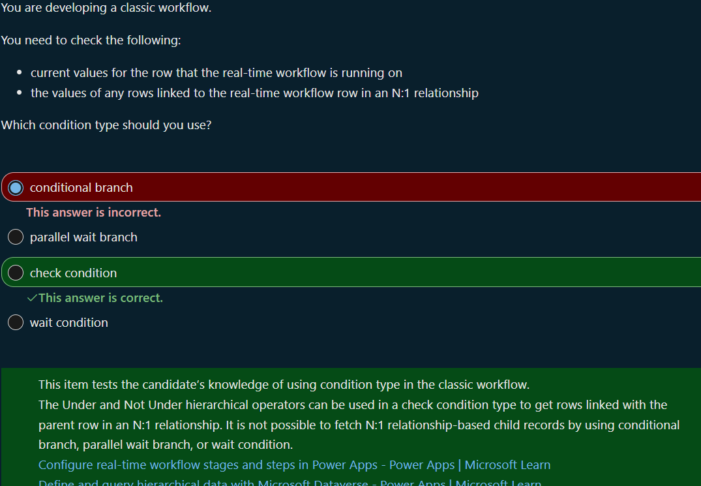

Power platform fundamentals
29 November 2025
23:17

